MECH 420 – Lab Report 3

Kyle Ah Von #57862609

## Part A

1. Provide one plot of force vs. displacement per type of spring.

1. Determine 𝐹(𝑥s) for each of the four springs;

0.210 N/mm Spring: F (N) = 5.039 (N) + 0.198 (N/mm) * x (mm)

0.420 N/mm Spring: F (N) = 3.790 (N) + 0.454 (N/mm) * x (mm)

0.665 N/mm Spring: F (N) = 0.726 (N/mm) * x (mm)

1.471 N/mm Spring: F (N) = 1.629 (N/mm) * x (mm)

## Part B

1. Find and plot the force 𝐹𝑉𝐶𝐴(𝑥𝑉𝐶𝐴) as a function of position for the different coil currents 𝐼𝑐𝑜𝑖𝑙

The force varies according to the motion of the coil. As the coil moves away, the Lorentz force increases pulling the force back to its original start position, however, past a point, the Lorentz force then helps push the coil away which results in lower forces.

1. Determine and plot 𝐵l (𝑥𝑉𝐶𝐴) for the different coil currents and compare 𝐵 with the “force constant” from the manufacturer.

Average experimental Bl constant: 8.98 N/A

Bl was calculated using this equation:

|  |  |
| --- | --- |
| Coil Current (A) | Bl Constant |
| 0.3 | 6.48 |
| 0.5 | 9.45 |
| 0.71 | 11.02 |

All the Bl constants are about the same at around 8.98 N/A, the value is smaller than the datasheet value at 10.2 N/A, however the values for different current values are about the same, showing that there indeed is a constant relationship between Force and Current.

1. Find and plot 𝑅(𝑥𝑉𝐶𝐴) for the different 𝐼𝑐𝑜𝑖𝑙 and compare with 𝑅 from the manufacturer.

Resistance was calculated using this equation:

|  |  |
| --- | --- |
| Coil Current (A) | Resistance (ohms) |
| 0.3 | 6.47 |
| 0.5 | 8.79 |
| 0.71 | 10.48 |

We can see that the Resistance spread is very tight which shows that the set up measured the varying components correctly. The Resistance can be said to be constant for each different coil current trial.

The Resistance at each displacement points for each coil current are calculated then averaged to 8.58 ohms. The datasheet resistance is 7.5 ohms which about 13% lower than the experimental value but which would within the borderline of what is experimentally acceptable.

1. Calculate 𝑍(𝑓), and plot |𝑍(𝑓)| and the phase. This will require curve fitting to the sinusoidal current and voltage signals to find current and voltage amplitude at each frequency as well as the phase between both signals.

There are more plots, but the fitting makes the image look like a red block. Here the parameters for all the fits:

|  |  |  |  |  |  |
| --- | --- | --- | --- | --- | --- |
| Frequency (Hz) | Type | Amplitude | Phase (radians) | Offset | R² Score |
| 1 | Voltage | 0.1678 | 2.1885 | 0.3195 | 0.9994 |
|  | Current | -0.0197 | -0.9611 | 0.2141 | 0.9891 |
| 5 | Voltage | 0.1681 | 4.7366 | 0.3171 | 0.9994 |
|  | Current | 0.0196 | -1.5671 | 0.2138 | 0.9883 |
| 10 | Voltage | -0.1680 | 0.1176 | 0.3167 | 0.9994 |
|  | Current | -0.0195 | 0.0734 | 0.2137 | 0.9887 |
| 20 | Voltage | 0.1682 | 0.4542 | 0.3164 | 0.9993 |
|  | Current | 0.0194 | 0.3708 | 0.2138 | 0.9887 |
| 50 | Voltage | 0.1654 | -2.2305 | 0.3163 | 0.9992 |
|  | Current | -0.0185 | 0.7252 | 0.2137 | 0.9860 |
| 100 | Voltage | 0.1584 | 1.8279 | 0.3163 | 0.9991 |
|  | Current | 0.0167 | 1.4723 | 0.2137 | 0.9840 |
| 200 | Voltage | -0.1658 | 0.3164 | 0.3114 | 0.9993 |
|  | Current | -0.0143 | -0.2624 | 0.2133 | 0.9791 |
| 400 | Voltage | 0.2048 | 1.2161 | 0.3115 | 0.9994 |
|  | Current | 0.0132 | 0.5019 | 0.2136 | 0.9749 |
| 600 | Voltage | -0.2456 | -0.4885 | 0.3113 | 0.9995 |
|  | Current | -0.0121 | -1.2624 | 0.2134 | 0.9720 |
| 800 | Voltage | -0.2809 | -0.1502 | 0.3122 | 0.9996 |
|  | Current | -0.0113 | -0.9164 | 0.2135 | 0.9686 |
| 1000 | Voltage | 0.3053 | -2.4011 | 0.3122 | 0.9997 |
|  | Current | -0.0108 | 0.0252 | 0.2139 | 0.9645 |

The table above also provides how well the data is fitted with a sine wave regardless of noise and other disturbances, which are all above 95%

Below are the parameters of impedance for each frequency value:

|  |  |  |  |  |
| --- | --- | --- | --- | --- |
| Frequency (Hz) | Impedance Magnitude (Ω) | Phase (°) | Real Part (R, Ω) | Imaginary Part (X, Ω) |
| 1.0 | 8.51 | 180.46 | -8.51 | -0.07 |
| 5.0 | 8.59 | 361.17 | 8.59 | 0.18 |
| 10.0 | 8.61 | 2.53 | 8.61 | 0.38 |
| 20.0 | 8.66 | 4.78 | 8.63 | 0.72 |
| 50.0 | 8.95 | -169.35 | -8.80 | -1.65 |
| 100.0 | 9.47 | 20.37 | 8.88 | 3.30 |
| 200.0 | 11.62 | 33.17 | 9.72 | 6.36 |
| 400.0 | 15.56 | 40.92 | 11.75 | 10.19 |
| 600.0 | 20.36 | 44.34 | 14.56 | 14.23 |
| 800.0 | 24.89 | 43.90 | 17.94 | 17.26 |
| 1000.0 | 28.17 | -139.02 | -21.27 | -18.47 |

The impedance magnitude is obtained using

The phase is obtained using φ = φ_voltage - φ_current

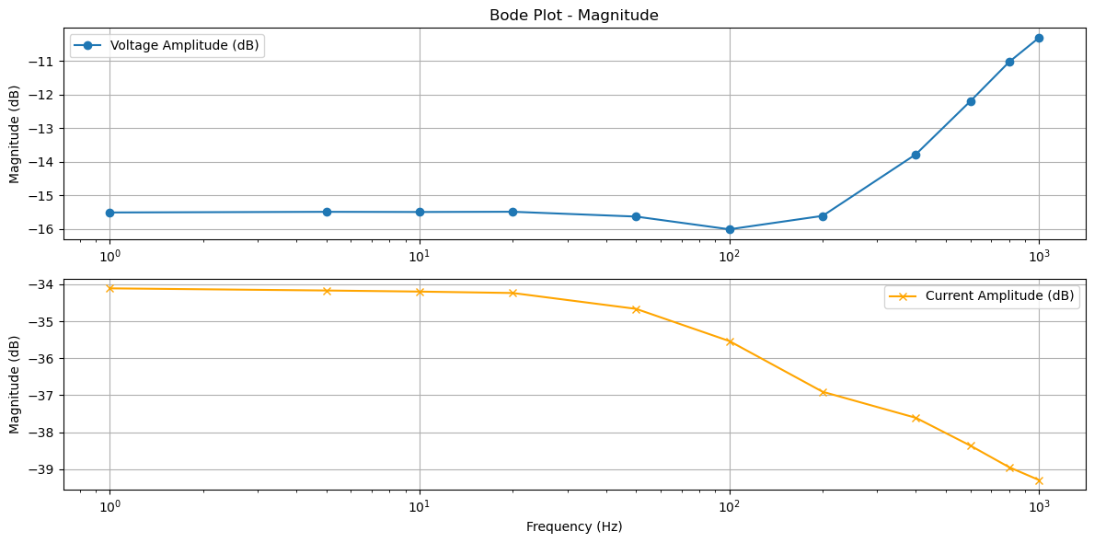

We can observe that the impedance magnitude increases with frequency, which can be explained by an increase in ω which is 2pi*frequency.

There is no obvious trend that can be determined in the impedance phase vs frequency.

1. With 𝑅 and 𝑍(𝑓) or |𝑍(𝑓)| from above, find 𝐿 using another curve fitting procedure. Also comment on the fit compared to the data from your measurements.

By fitting the equation , L can be obtained as a fitted coefficient. L = 5mH

1. Compare with 𝐿 from the data sheet.

L given in the datasheet is 3.3mH and the experimentally determined L is 5mH which is about 30% off the specified value. The disparity could be explained by how much noise was presenting the data and losses through different circuit components.